Law Enforcement Activity in San Francisco, 2018-2024
Peter Amerkhanian
2024-02-17
Abstract
In this memo I analyze trends in law enforcement actions – police incident reports that result in arrest or citation – in San Francisco before, during, and after the COVID-19 Pandemic (2018-2024). Enforcement actions decreased before the pandemic, sharply dropped at the outset of the pandemic, and have been consistently low in the post-pandemic.
Enforcement levels for almost every specific class of crime decreased during the analysis period, except for law enforcement actions related to drug sale, which substantially increased. The vast majority of those increased drug sale enforcement actions took place in the Tenderloin. Indeed, the Tenderloin was an exception to the trend of decreasing enforcement levels in San Francisco – law enforcement actions in the district increased in the post-pandemic, with drug sale enforcement actions driving the increase.
An important caveat of this analysis is that it examines enforcement actions, a combination of arrests and citations, not crime. Of all crime events, arrests and citations only include those events that are reported to law enforcement and go on to produce an arrest or citation. These trends do not necessarily point to equal trends in crime, rather they point to trends in how the City and Police Department are prioritizing law enforcement resources, specifically policing. Thus I conclude that in the post-pandemic, the City shifted policing resources towards the Tenderloin and prioritized making arrests and issuing citations for drug sale crime.

Geographic concentration in the Tenderloin
Figure 1 shows that law enforcement actions were geographically concentrated in the Tenderloin district over the six-year analysis period. The left-hand panel depicts the general concentration of enforcement actions in downtown police districts – Northern, Central, Southern, the Tenderloin, and the Mission. However, viewing the geographic trends by district obscures more specific patterns illustrated at a block-level in the right panel. Law enforcement actions along the Northern, Central, and Southern districts’ borders with the Tenderloin accounted for the high numbers in those districts.
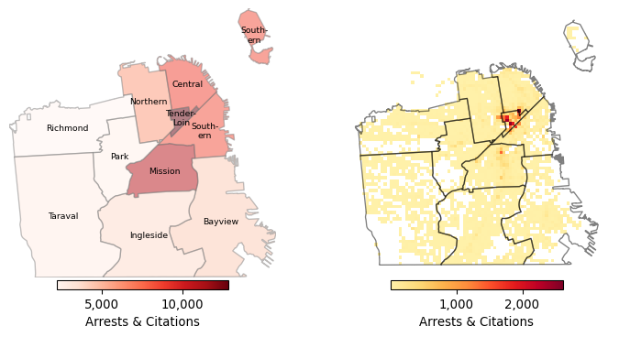
Figure 1: Geographic Trends in Law Enforcement Actions (2018-2024), by Police District (Left) and by Block Segment (Right)
At the block level, we can specifically classify “the greater Tenderloin,” the area inside of the Tenderloin plus the corners along its border streets, as having particularly high law enforcement activity. The greater Tenderloin represents 1.01% of the square miles of San Francisco, but made up 27% of the total law enforcement actions in the City during the analysis period. Of the top ten street corners in San Francisco ranked by total enforcement actions 2018-2024, shown in Figure 2, almost all of them were in the greater Tenderloin.
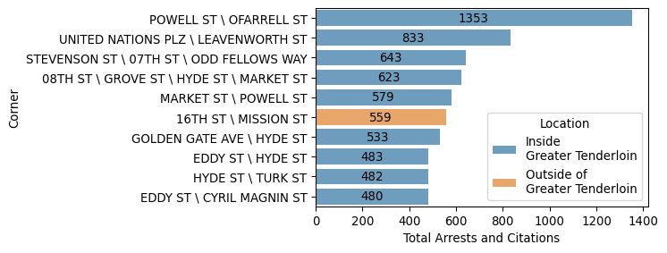
Figure 2: Ten Corners with the Highest Law Enforcement Activity (2018-2024)

Changes in post-pandemic arrest patterns
The onset of the pandemic and the accompanying city-wide shelter-in-place order were associated with a large drop in law enforcement activity at the city level. Between February and April 2020 – the immediate outset of the pandemic – monthly enforcement actions decreased by 43% (-441 arrests/citations) in San Francisco. This trend aligns with prior study of the pandemic’s effects on crime and policing. In a national analysis that included San Francisco and 11 other major cities, Abrams (2021) found that shelter-in-place orders and the pandemic itself caused substantial and immediate reductions in many types of criminal behavior and their accompanying arrest activity.
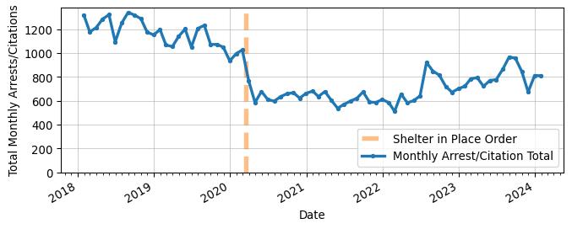
Figure 3: Monthly Arrest Totals, City-wide, 2018-2024
That short-term drop in law enforcement activity in 2020 can be tied to the immediate disruptions of the Pandemic. However, it is not clear why activity remained depressed for years after the onset of the pandemic. Table 1 defines two distinct, two-year periods:
- the “pre-pandemic,” 1/1/2018-1/1/2020, and
- the “post-pandemic,” 1/1/2022-1/1/2024
The table shows that average weekly enforcement actions in the post-pandemic period were still down -36% from the pre-pandemic.
Table 1: Weekly Arrest Totals in the pre/post pandemic
Time Period | Average Weekly Arrest/Citation Total | Difference | Percent
Pre Pandemic (2018-20) | 269 | - | -
Post Pandemic (2022-24) | 171 | -98 | -36%

The general decrease in law enforcement activity in the post-pandemic was driven by a large decrease in enforcement actions for traffic violations, down -19.82 a week on average. Enforcement actions for larceny theft and some violent crimes – robbery and assault – also decreased.
In the post-pandemic, homicide, burglary, weapons, and drug-use enforcement actions all returned to or else never deviated from pre-pandemic levels. Their average weekly enforcement activity levels in the post-pandemic were not statistically distinguishable from the pre-pandemic.
Sale of drugs was the only incident category where enforcement activity significantly increased in the post-pandemic. Enforcement actions tied to the sale of drugs increased by 7.43 a week on average. It is notable that drug sale enforcement activity increased while drug-use enforcement activity seemingly did not. Figure 4 shows trends for each incident type, using a statistical approach detailed in the Methods Appendix Section 4.
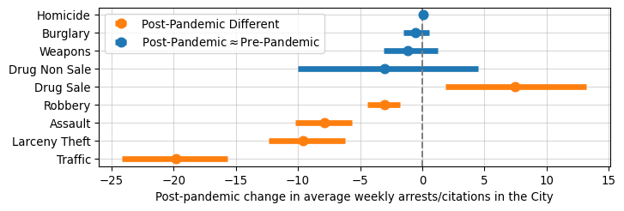
Figure 4: Change in Average Weekly Arrests/Citations, 2018-2020 to 2022-2024
In the post-pandemic, 73% of all drug sale enforcement actions in the City took place in the greater Tenderloin. The greater Tenderloin is also the only region in the city where enforcement activity returned to and in some months exceeded pre-pandemic levels. Other districts generally saw levels drop slightly, or, in the Mission’s case, drop significantly.
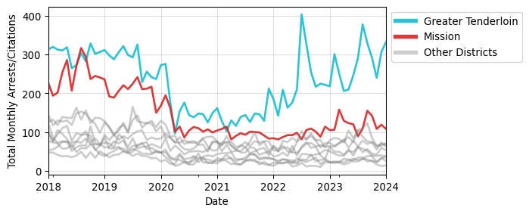
Figure 5: Monthly Arrest Totals by District, 2018-2024
The greater Tenderloin also saw a meaningful change in the composition of enforcement activity in the post-pandemic, marked by a growing emphasis on drug sale enforcement actions. Figure 6 shows that for most incident types in the greater Tenderloin, average weekly levels were essentially equal in the pre and post-pandemic. Drug use enforcement activity rose on its face, but the increase was not statistically significant, suggesting that the weekly totals were highly variable and not consistently elevated.
Drug sale enforcement activity saw a large and statistically significant increase, with 6.7 more actions a week on average in the post-pandemic. This increase is consistent with media coverage of the City’s aggressive approach to drug crime in the Tenderloin. Neilson (2023) also suggests that policing in the Tenderloin was more aggressive in the post-pandemic, with a particular focus on making arrests for drug sale.
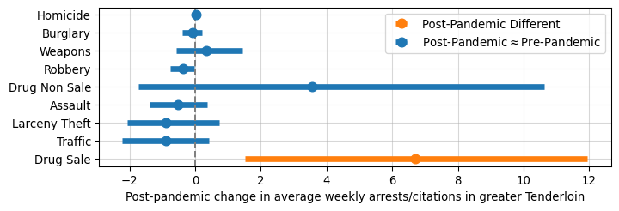
Figure 6: Change in Average Weekly Arrests in the Tenderloin, 2018-2020 to 2022-2024

Discussion
I conclude that in the post-pandemic, the City shifted law enforcement activity towards the Tenderloin and prioritized enforcement actions for drug sale in that district. To be clear, the political and administrative focus on the Tenderloin, and particularly on drug crime in the Tenderloin, is not novel (Hartlaub 2022). However, I newly document the degree to which the City, in the post-pandemic, emphasized law enforcement in the Tenderloin relative to 2018-2020 pre-pandemic trends. The gap in law enforcement activity levels between the greater Tenderloin and all other regions in the City grew considerably. This shift in policing resources could have been in response to rising drug sale crime in the Tenderloin, but further research using criminal incident data is necessary to confirm any trends in crime.

Appendix

Data Appendix
I based all analysis on publicly available police incident data from the City of San Francisco (DataSF 2024). Of the 824,565 records in the incident data extract, many are duplicates or else incidents that did not lead to arrest or citation. I applied filtering to isolate the 119,119 records that represent unique arrests/citations between 01-01-2018 and 02-16-2024. I then filtered the dataset to isolate arrests where geographic point data is available – 118,506 unique arrests/citations. The vast majority of the 613 arrests/citations with missing point data took place outside of San Francisco. The negligible arrests/citations with missing point data within San Francisco were distributed across districts proportional to their totals, suggesting that dropping missing point data did not bias arrests/citations down in any particular region.

Defining the greater Tenderloin
I define the “greater Tenderloin” by placing a small buffer around the Tenderloin shape to encompass the corners along its immediate edges. See Figure 7 below. The buffered area is added to the Tenderloin and removed from the adjoining districts. The Tenderloin is the only district that I apply this buffering to because no other district has such intense spillover of enforcement actions along its borders.
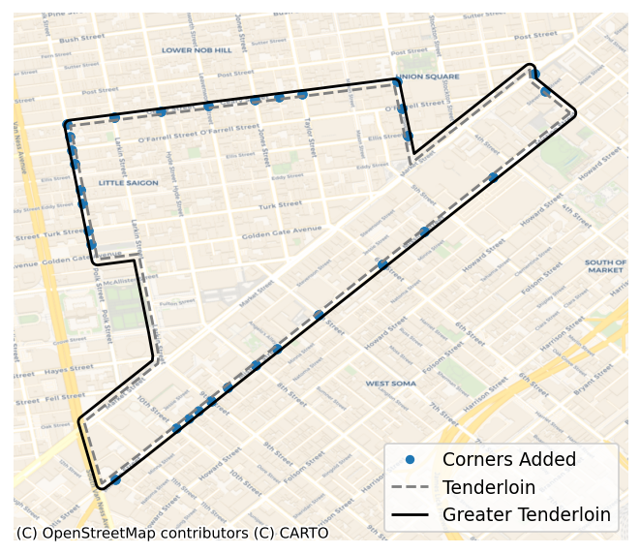
Figure 7: The Greater Tenderloin

Defining “Drug use” enforcement actions
In the incident report data, there is a category, “Drug,” which contains all drug related enforcement actions. I split this category into two sub-groups – drug sale enforcement, and drug use/non sale enforcement. All enforcement actions in the broad “Drug” category are also members of one of these two subgroups. I define Drug use, or, non-drug sale enforcement actions, as those drug incidents that do not contain the phrase “sale” in their description.
Drug Use Enforcement Description | Frequency
Narcotics Paraphernalia, Possession of | 4,349
Methamphetamine Offense | 1,446
Controlled Substance Offense | 318
Heroin Offense | 298
Opiates Offense | 284
Loitering Where Narcotics are Sold/Used | 249
Cocaine, Base/rock Offense | 231
Marijuana Offense | 227
Firearm, Armed While Possessing Controlled Substance | 207
Cocaine Offense | 161
Controlled Substance, Under the Influence of | 122
Methamphetamine, Transportation | 39
Controlled Substance Violation, Loitering for | 24
Cocaine, Transportation | 21
Hallucinogenics Offense | 20
Marijuana, Transporting | 20
Controlled Substance, Transportation | 12
Methadone Offense | 11
Amphetamines Offense | 11
Opiates, Transportation | 10
Maintain Premise Where Narcotics Are Sold/used | 10
Heroin, Transportation | 9
Opium Offense | 8
Opium Derivative Offense | 6
Marijuana, Cultivating/Planting | 4
Marijuana, Furnishing | 4
Drug Lab Apparatus, Possession | 3
Hypodermic Needle or Syringe, Possession | 2
Narcotics Addict, Failure To Register | 2
Barbiturates, Possession | 2
Prescription, Forge Or Alter (11368 H&S) | 2
Barbiturates Offense | 1
Controlled Substance, Presence Where Used | 1
Barbiturates, Transportation | 1

Defining “Drug sale” enforcement
Drug sale enforcement actions are those incidents in the “Drugs” category that contain the word “sale” in their description.
Drug Sale Enforcement Description | Frequency
Methamphetamine, Possession For Sale | 2,063
Cocaine, Base/rock, Possession For Sale | 1,862
Heroin, Possession For Sale | 1,429
Opiates, Possession For Sale | 898
Controlled Substance, Possession For Sale | 880
Cocaine, Base/rock, Sale | 523
Cocaine, Possession For Sale | 430
Methamphetamine, Sale | 252
Controlled Substance, Sale | 232
Marijuana, Possession For Sale | 182
Heroin, Sales | 133
Opiates, Sale | 108
Hallucinogenic, Possession For Sale | 62
Hallucinogenic, Sale | 45
Methadone, Possession For Sale | 41
Marijuana, Sales | 29
Cocaine, Sale | 18
Sales of Cocaine Base/Schoolyard Trafficking Act Violation | 11
Opium, Possession For Sale | 7
Amphetamine, Possession For Sale | 5
Opium Derivative, Possession For Sale | 3

Methods Appendix
In this memo, I used the following core statistical test for examining changes in law enforcement activity:
$$actions_{t}=\hat{β_{0}}+\hat{β_{1}}post_{t}+ϵ_{t} \left(1\right)$$
The estimate of interest is $\hat{β_{1}}$, which represents the average increase in weekly enforcement actions in the post-pandemic, 2022-2024, relative to the pre-pandemic, 2018-2020. $\hat{β_{0}}$ is the average of weekly enforcement actions in the pre-pandemic and $\hat{β_{0}}+\hat{β_{1}}$ is the average of weekly enforcement actions in the post-pandemic. I test the hypothesis that the average of weekly enforcement actions in the post-pandemic was different from the average of weekly enforcement actions in the pre-pandemic:
$$H_{0}:β_{1}=0, H_{1}:β_{1}≠0 \left(2\right)$$
I repeat the estimation of Equation 1 and test Equation 2 for each arrest type, a total of 9 times, once at the city-level, and once in the greater Tenderloin. I obtain the standard errors presented in the memo via a block bootstrap procedure, with weeks clustered into four-unit groups to address autocorrelation in the week-level time series.
Repeated hypothesis testing introduces the issue of multiple testing, where every additional test we conduct raises the probability that we made a false discovery of change (James et al. 2021, chap 13). To adjust for multiple testing, I apply a Bonferroni correction to the hypothesis tests. Specifically, for a 95% confidence interval, where one would typically test with a threshold for the probability of a false positive, $α=.05$, the Bonferroni correction instead tests with $α=.05/m$, where $m$ is the number of hypotheses being tested (James et al. 2021, chap 13). In this case, $m=$ 9, implying a threshold $.05/$ 9 $=$ 0.0056 and confidence intervals that cover 99.44%.

Robustness checks
One potential issue with the modeling approach is that the Bonferroni correction can be overly conservative when the amount of hypotheses being tested is very large or sample sizes are very small. However, in this setting, where only 9 related hypotheses are being tested and the week-level time series is not especially small at $n=$ 313, the Bonferroni correction can still be an appropriate adjustment (VanderWeele and Mathur 2019). Regardless, to test if the conservatism of the correction meaningfully changes the results of the policy analysis, I fit models with and without it.
I also conduct robustness checks on the standard error specification. In the memo, I present the block-bootstrap standard errors because they rely on minimal assumptions about the structure of the data. However, I present results from two alternatives – Newey-West standard errors, and ordinary least squares (OLS) standard errors – to test robustness of the findings.
Each of these specifications are theoretically inferior to the block-bootstrap approach, but the use of mis-specified OLS is so common in practice as to merit inclusion. Equation 1, when estimated using ordinary least squares (OLS), produces standard errors valid under the following assumptions:
- The error term is normally distributed with constant variance and mean zero: $ϵ∼N\left(0,σ^{2}\right)$.
- Weekly arrests are continuous and distributed normally: $actions∈R$ and $actions∼N\left(μ,σ^{2}\right)$
In the context of weekly enforcement action totals, which are a time-series that exhibit autocorrelation, the first assumption of constant variance may be problematic. Both Newey-West estimation and the block bootstrap are robust to this issue. Enforcement action count data, which are typically small, positive integers, don’t conform to the structure set forth in the second assumption. The block bootstrap is the only specification present that is robust to this issue. Thus, the bootstrap should be the best approach under the circumstances.

Results
Table 2 shows that changing testing specifications has no impact on any statistical or policy conclusions made at the City-level in the memo.
Table 3 shows that testing specification does not affect core conclusions about drug sale enforcement in the greater Tenderloin. However, specification does affect the conclusion presented in the memo that larceny theft, robbery, traffic and drug use enforcement actions did not change in the greater Tenderloin in the post-pandemic. Much of this is due to the fact that OLS becomes an increasingly tenuous approach in the Tenderloin, where weekly enforcement action counts are often small and clustered near 0, a clear challenge to OLS modeling assumptions.
- Drug use: using OLS with no Bonferroni correction yields a statistically significant increase in drug use enforcement actions. This is a mis-specified test that does not take into account the structure of the data or possible multiple testing issues. All other tests concluded that there was no statistically significant change. Still, the effect is not trivially small, so I temper my conclusion that this enforcement action class did not increase and encourage further research into this arrest type in particular.
- Larceny theft: similarly, using OLS with no Bonferroni correction yields a statistically significant estimate, while all other tests conclude there was no change. In this case, the change is also practically negligible (less than one arrest a week). In the memo , I report no change in larceny theft enforcement actions in the greater Tenderloin.
- Robbery: every specification that does not utilize the Bonferroni correction yields a small, statistically significant decrease, and every specification with the correction yields no change. In this case, a next step would be using a less conservative correction for multiple testing (James et al. 2021, chap 13). However, given that the effect size is particularly small, I defer to the core specification and report no change in the memo.
- Traffic: tests present a mixed bag and a practically negligible effect size. In the memo I defer to conclusions of the core bootstrap specification.
Table 2: Full City – robustness checks for changes in arrest activity
 |  | Coefficient | Lower bound | Upper bound | Significant
Outcome | Model
Assault | Block Bootstrap (block=4) | -7.876190 | -10.182692 | -5.634615 | True
 | Block Bootstrap, no Bonferroni | -7.876190 | -9.509615 | -6.259615 | True
 | Newey West (lags=3) | -7.876200 | -11.169000 | -4.584000 | True
 | Newey West, no Bonferroni | -7.876200 | -10.193000 | -5.560000 | True
 | OLS | -7.876200 | -10.985000 | -4.768000 | True
 | OLS, no Bonferroni | -7.876200 | -10.063000 | -5.689000 | True
Burglary | Block Bootstrap (block=4) | -0.523810 | -1.540625 | 0.569471 | False
 | Block Bootstrap, no Bonferroni | -0.523810 | -1.250000 | 0.288462 | False
 | Newey West (lags=3) | -0.523800 | -1.652000 | 0.604000 | False
 | Newey West, no Bonferroni | -0.523800 | -1.317000 | 0.270000 | False
 | OLS | -0.523800 | -1.708000 | 0.661000 | False
 | OLS, no Bonferroni | -0.523800 | -1.357000 | 0.310000 | False
Drug Non Sale | Block Bootstrap (block=4) | -3.066667 | -10.041827 | 4.506490 | False
 | Block Bootstrap, no Bonferroni | -3.066667 | -8.115625 | 2.307692 | False
 | Newey West (lags=3) | -3.066700 | -10.623000 | 4.490000 | False
 | Newey West, no Bonferroni | -3.066700 | -8.383000 | 2.250000 | False
 | OLS | -3.066700 | -7.997000 | 1.863000 | False
 | OLS, no Bonferroni | -3.066700 | -6.535000 | 0.402000 | False
Drug Sale | Block Bootstrap (block=4) | 7.428571 | 1.889904 | 13.209615 | True
 | Block Bootstrap, no Bonferroni | 7.428571 | 3.432692 | 11.740385 | True
 | Newey West (lags=3) | 7.428600 | 2.006000 | 12.851000 | True
 | Newey West, no Bonferroni | 7.428600 | 3.614000 | 11.243000 | True
 | OLS | 7.428600 | 2.813000 | 12.044000 | True
 | OLS, no Bonferroni | 7.428600 | 4.181000 | 10.676000 | True
Homicide | Block Bootstrap (block=4) | 0.047619 | -0.059856 | 0.153846 | False
 | Block Bootstrap, no Bonferroni | 0.047619 | -0.038462 | 0.115385 | False
 | Newey West (lags=3) | 0.047600 | -0.058000 | 0.154000 | False
 | Newey West, no Bonferroni | 0.047600 | -0.027000 | 0.122000 | False
 | OLS | 0.047600 | -0.053000 | 0.148000 | False
 | OLS, no Bonferroni | 0.047600 | -0.023000 | 0.118000 | False
Larceny Theft | Block Bootstrap (block=4) | -9.571429 | -12.384615 | -6.211538 | True
 | Block Bootstrap, no Bonferroni | -9.571429 | -11.740385 | -7.384615 | True
 | Newey West (lags=3) | -9.571400 | -12.820000 | -6.323000 | True
 | Newey West, no Bonferroni | -9.571400 | -11.857000 | -7.286000 | True
 | OLS | -9.571400 | -12.127000 | -7.016000 | True
 | OLS, no Bonferroni | -9.571400 | -11.369000 | -7.773000 | True
Robbery | Block Bootstrap (block=4) | -3.066667 | -4.396394 | -1.788462 | True
 | Block Bootstrap, no Bonferroni | -3.066667 | -4.019231 | -2.163462 | True
 | Newey West (lags=3) | -3.066700 | -4.298000 | -1.835000 | True
 | Newey West, no Bonferroni | -3.066700 | -3.933000 | -2.200000 | True
 | OLS | -3.066700 | -4.181000 | -1.953000 | True
 | OLS, no Bonferroni | -3.066700 | -3.850000 | -2.283000 | True
Traffic | Block Bootstrap (block=4) | -19.819048 | -24.129327 | -15.685817 | True
 | Block Bootstrap, no Bonferroni | -19.819048 | -22.884615 | -16.846154 | True
 | Newey West (lags=3) | -19.819000 | -23.714000 | -15.924000 | True
 | Newey West, no Bonferroni | -19.819000 | -22.559000 | -17.079000 | True
 | OLS | -19.819000 | -22.734000 | -16.905000 | True
 | OLS, no Bonferroni | -19.819000 | -21.870000 | -17.769000 | True
Weapons | Block Bootstrap (block=4) | -1.171429 | -3.127163 | 1.240385 | False
 | Block Bootstrap, no Bonferroni | -1.171429 | -2.461538 | 0.586538 | False
 | Newey West (lags=3) | -1.171400 | -3.618000 | 1.276000 | False
 | Newey West, no Bonferroni | -1.171400 | -2.893000 | 0.550000 | False
 | OLS | -1.171400 | -3.401000 | 1.058000 | False
 | OLS, no Bonferroni | -1.171400 | -2.740000 | 0.397000 | False

Table 3: Greater Tenderloin – robustness checks for changes in arrest activity
 |  | Coefficient | Lower bound | Upper bound | Significant
Outcome | Model
Assault | Block Bootstrap (block=4) | -0.533333 | -1.403846 | 0.367548 | False
 | Block Bootstrap, no Bonferroni | -0.533333 | -1.144231 | 0.096154 | False
 | Newey West (lags=3) | -0.533300 | -1.650000 | 0.583000 | False
 | Newey West, no Bonferroni | -0.533300 | -1.319000 | 0.252000 | False
 | OLS | -0.533300 | -1.626000 | 0.560000 | False
 | OLS, no Bonferroni | -0.533300 | -1.302000 | 0.236000 | False
Burglary | Block Bootstrap (block=4) | -0.076190 | -0.394231 | 0.201923 | False
 | Block Bootstrap, no Bonferroni | -0.076190 | -0.307692 | 0.115385 | False
 | Newey West (lags=3) | -0.076200 | -0.397000 | 0.245000 | False
 | Newey West, no Bonferroni | -0.076200 | -0.302000 | 0.149000 | False
 | OLS | -0.076200 | -0.377000 | 0.225000 | False
 | OLS, no Bonferroni | -0.076200 | -0.288000 | 0.136000 | False
Drug Non Sale | Block Bootstrap (block=4) | 3.561905 | -1.723317 | 10.627163 | False
 | Block Bootstrap, no Bonferroni | 3.561905 | -0.326923 | 8.557692 | False
 | Newey West (lags=3) | 3.561900 | -2.601000 | 9.725000 | False
 | Newey West, no Bonferroni | 3.561900 | -0.774000 | 7.898000 | False
 | OLS | 3.561900 | -0.054000 | 7.178000 | False
 | OLS, no Bonferroni | 3.561900 | 1.018000 | 6.106000 | True
Drug Sale | Block Bootstrap (block=4) | 6.704762 | 1.521154 | 11.954087 | True
 | Block Bootstrap, no Bonferroni | 6.704762 | 3.115385 | 10.442308 | True
 | Newey West (lags=3) | 6.704800 | 1.774000 | 11.636000 | True
 | Newey West, no Bonferroni | 6.704800 | 3.236000 | 10.174000 | True
 | OLS | 6.704800 | 2.671000 | 10.738000 | True
 | OLS, no Bonferroni | 6.704800 | 3.867000 | 9.542000 | True
Homicide | Block Bootstrap (block=4) | 0.009524 | 0.000000 | 0.048077 | False
 | Block Bootstrap, no Bonferroni | 0.009524 | 0.000000 | 0.028846 | False
 | Newey West (lags=3) | 0.009500 | -0.017000 | 0.036000 | False
 | Newey West, no Bonferroni | 0.009500 | -0.009000 | 0.028000 | False
 | OLS | 0.009500 | -0.017000 | 0.036000 | False
 | OLS, no Bonferroni | 0.009500 | -0.009000 | 0.028000 | False
Larceny Theft | Block Bootstrap (block=4) | -0.885714 | -2.081250 | 0.732933 | False
 | Block Bootstrap, no Bonferroni | -0.885714 | -1.769231 | 0.240385 | True
 | Newey West (lags=3) | -0.885700 | -2.504000 | 0.732000 | False
 | Newey West, no Bonferroni | -0.885700 | -2.024000 | 0.253000 | False
 | OLS | -0.885700 | -1.993000 | 0.222000 | False
 | OLS, no Bonferroni | -0.885700 | -1.665000 | -0.106000 | True
Robbery | Block Bootstrap (block=4) | -0.361905 | -0.761779 | -0.019231 | False
 | Block Bootstrap, no Bonferroni | -0.361905 | -0.644231 | -0.125000 | True
 | Newey West (lags=3) | -0.361900 | -0.750000 | 0.027000 | False
 | Newey West, no Bonferroni | -0.361900 | -0.635000 | -0.089000 | True
 | OLS | -0.361900 | -0.748000 | 0.024000 | False
 | OLS, no Bonferroni | -0.361900 | -0.634000 | -0.090000 | True
Traffic | Block Bootstrap (block=4) | -0.895238 | -2.221154 | 0.403846 | False
 | Block Bootstrap, no Bonferroni | -0.895238 | -1.807692 | -0.057692 | False
 | Newey West (lags=3) | -0.895200 | -1.959000 | 0.169000 | False
 | Newey West, no Bonferroni | -0.895200 | -1.644000 | -0.147000 | True
 | OLS | -0.895200 | -1.716000 | -0.074000 | True
 | OLS, no Bonferroni | -0.895200 | -1.473000 | -0.318000 | True
Weapons | Block Bootstrap (block=4) | 0.342857 | -0.569471 | 1.434856 | False
 | Block Bootstrap, no Bonferroni | 0.342857 | -0.307933 | 1.115385 | False
 | Newey West (lags=3) | 0.342900 | -0.622000 | 1.308000 | False
 | Newey West, no Bonferroni | 0.342900 | -0.336000 | 1.022000 | False
 | OLS | 0.342900 | -0.548000 | 1.233000 | False
 | OLS, no Bonferroni | 0.342900 | -0.284000 | 0.969000 | False

References
Abrams, David S. 2021. “COVID and Crime: An Early Empirical Look.” Journal of Public Economics 194 (February): 104344. https://doi.org/10.1016/j.jpubeco.2020.104344.
DataSF. 2024. “SFPD Incident Report: 2018 to Present.” Dataset Explainers. https://datasf.gitbook.io/datasf-dataset-explainers/sfpd-incident-report-2018-to-present.
Hartlaub, Peter. 2022. “Culture, Protest and an Earthquake-Proof Bank: A Century of Stories from S.F.’s Tenderloin.” The San Francisco Chronicle, February. https://www.sfchronicle.com/projects/2022/san-francisco-tenderloin-history.
James, Gareth, Daniela Witten, Trevor Hastie, and Robert Tibshirani. 2021. An Introduction to Statistical Learning: With Applications in R. 2nd ed. 2021 edition. New York, NY: Springer.
Neilson, Aldo Toledo, Susie. 2023. “S.F. Drug Arrests Are the Highest They’ve Been in a Decade. Here’s Why.” San Francisco Chronicle, September. https://www.sfchronicle.com/sf/article/tenderloin-drug-arrests-18327055.php.
VanderWeele, Tyler J, and Maya B Mathur. 2019. “SOME DESIRABLE PROPERTIES OF THE BONFERRONI CORRECTION: IS THE BONFERRONI CORRECTION REALLY SO BAD?” American Journal of Epidemiology 188 (3): 617–18. https://doi.org/10.1093/aje/kwy250.

A map defining the “greater Tenderloin” is available in Appendix Section 4.1.1
The U.S. reported its first COVID-19 case in January 2020
“Drug-use enforcement actions” are defined in Appendix Section 4.1.2
“Drug-sale enforcement actions” are defined in Appendix Section 4.1.3
$CI=1−α=1−.05=.95$

